Open Git

navigate to the directory where you want to save the project

ex:

cd Documents/”UMSL – MBA”/”SCMA 6345”

note: you need quotation marks only if the file path contains spaces

Create a clone of the github repository

Git clone <https://github.com/jrkkv5/Default_Risk_Project.git>

Navigate to newly cloned repoditory

Cd Default_Risk_Project

#check the status of the file

Git status

Should see something like this

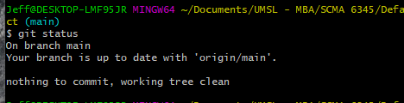

Now you should see this folder in your directory on your local machine.



Create/update a file like you normally would through jupyter notebook.

Too add a newly created file to the repository

Git add Hello.ipynb

Git commit -m “added Hello.ipynb”

#make sure to add a meaningful message after the -m, so that others know what changes you are commiting to the repository.

Git push

#pushes changes to the main branch for approval by the repository owner.

Git pull

#pulls changes made by other users to your local version of the repository